Introduction

Mesh Topology
Mesh topology is a networking design where each device (node) is connected directly to every other device in the network. This creates multiple paths for data to travel, enhancing reliability and fault tolerance.
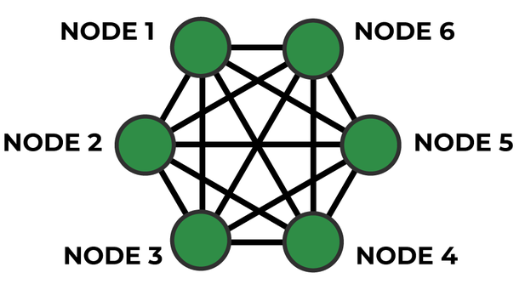

Characteristics
- Redundancy: Multiple paths between nodes ensure data can reach its destination even if one path fails.
- Self-healing: If a node or connection fails, the network automatically reroutes traffic through alternative paths.
- Scalability: Easily scalable by adding new nodes without disrupting existing connections.
- Reliability: High reliability due to the distributed nature of connections.
Advantages of Mesh Topology
- Robustness: Resilient to failures, making it suitable for critical applications.
- Flexibility: Supports dynamic changes in network topology and node connectivity.
- High Performance: Efficient data routing leads to faster communication.
- Security: Enhanced security through multiple paths and decentralized architecture.
Applications
- IoT Networks: Ideal for IoT deployments where devices need to communicate reliably over a wide area.
- Sensor Networks: Used in environmental monitoring, smart cities, and industrial automation.
- Military and Disaster Recovery: Deployed in scenarios requiring robust and fault-tolerant communication.
Types of Mesh Networks
Full Mesh Network | Partial Mesh Network
In a full mesh network, every node is directly connected to every other node. This results in a fully interconnected network topology.  Characteristics:  - High redundancy and fault tolerance.  - Complex to set up and manage due to the large number of connections.  - Suitable for small networks or critical applications where reliability is paramount. | A partial mesh network is a compromise between a full mesh and a point-to-point topology. Not every node is directly connected to every other node, but there are multiple paths between nodes.  Characteristics:  - Balances redundancy with scalability and manageability.  - Nodes are strategically connected to ensure alternative paths for data transmission.  - Commonly used in medium-sized networks or scenarios where full mesh is impractical.  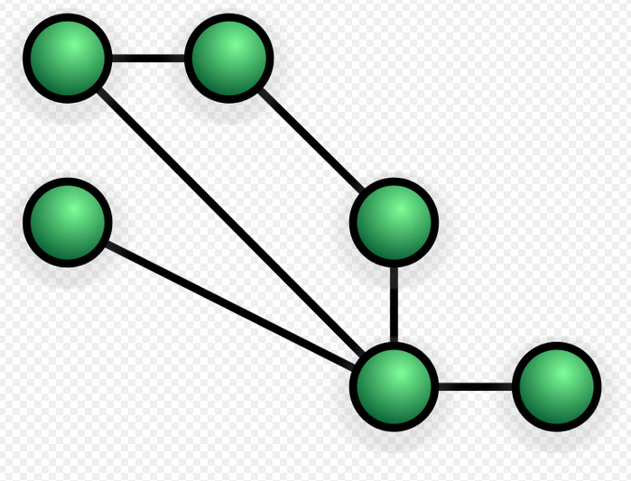

LoRa Mesh Networks
Introduction to LoRa Mesh Networks:
- LoRa (Long Range) technology has revolutionized the field of IoT by providing long-range, low-power communication solutions. LoRa mesh networks further enhance these capabilities by leveraging the mesh topology.
Benefits of LoRa Mesh Networks:
- Scalability: LoRa mesh networks are highly scalable, allowing for the addition of new nodes without disrupting existing connections. This scalability makes them suitable for both small-scale deployments and large-scale IoT networks.
- Extended Range: The mesh topology in LoRa networks extends the range of communication by allowing nodes to relay data for each other. This ensures that even devices located far from a gateway can communicate effectively.
- Robustness: Mesh networks offer built-in redundancy, meaning if one node or communication path fails, data can still reach its destination through alternative routes. This self-healing capability improves network reliability.
- Low Power Consumption: Like traditional LoRa networks, LoRa mesh networks are designed for low power consumption. Nodes can operate on battery power for extended periods, reducing maintenance and operational costs.
- Dynamic Routing: Mesh networks use dynamic routing algorithms to determine the most efficient paths for data transmission. This adaptive routing ensures optimal performance even in changing network conditions.
Components of a LoRa Mesh Network:
- LoRa Nodes: Devices equipped with LoRa transceivers that can communicate wirelessly within the network. Nodes can act as both endpoints and routers, relaying data for other nodes.
- Gateways: Gateways serve as the bridge between LoRa nodes and external networks, such as the Internet. They receive data from nodes and forward it to the appropriate destination.
- Network Server: The network server manages the communication between nodes, gateways, and external applications. It handles tasks such as data routing, device management, and security.
- Application Layer: External applications interact with the LoRa mesh network through the application layer. This layer includes APIs, protocols, and interfaces for data exchange and control.
Applications of LoRa Mesh Networks:
- Smart Cities: LoRa mesh networks enable smart city applications such as smart lighting, environmental monitoring, waste management, and traffic control. The extended range and scalability of mesh networks make them ideal for city-wide deployments.
- Industrial IoT: In industrial settings, LoRa mesh networks support asset tracking, predictive maintenance, and monitoring of equipment and machinery. The robustness and reliability of mesh networks are crucial for industrial applications.
- Agriculture: LoRa mesh networks play a vital role in smart agriculture by monitoring soil moisture, weather conditions, crop health, and irrigation systems. The ability to cover large agricultural areas makes mesh networks well-suited for farm deployments.
- Disaster Recovery: During emergencies or natural disasters, LoRa mesh networks provide reliable communication infrastructure for disaster recovery efforts. The self-healing capabilities of mesh networks ensure continuous communication even in challenging conditions.
LoRa mesh networks offer a versatile and robust solution for a wide range of IoT applications. With their scalability, extended range, low power consumption, and resilience, LoRa mesh networks are shaping the future of connected devices and smart systems.
comparison table for LoRaWAN and LoRa Mesh networks:
Feature | LoRaWAN | LoRa Mesh
Network Architecture | Star topology with centralized network server  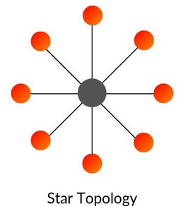 | Mesh topology with decentralized routing  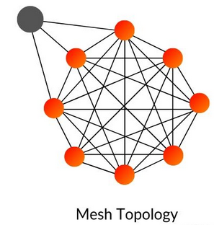
Range | Up to several kilometers in rural areas | Extended range through mesh routing
Scalability | Highly scalable for large-scale deployments | Scalable for both small and large networks
Reliability | Reliable with end-to-end communication | Robust with self-healing mesh architecture
Power Consumption | Low power consumption for battery devices | Low power consumption for battery devices
Network Management | Centralized network server for device management | Decentralized routing with dynamic routing
Deployment Cost | Initial setup cost for network infrastructure | Lower infrastructure cost for mesh routing
Use Cases | Wide-area IoT applications, smart cities | Large-scale IoT deployments, industrial IoT

Silvanet Mesh Network

- The Silvanet System is a comprehensive network comprising both hardware and software components.
- It includes the Silvanet Mesh Network, which utilizes Mesh Gateways to transmit data from sensors deep within forests to Border Gateways. The Border Gateways then relay this information to the Silvanet Cloud via Ethernet, mobile networks, or satellite connections.

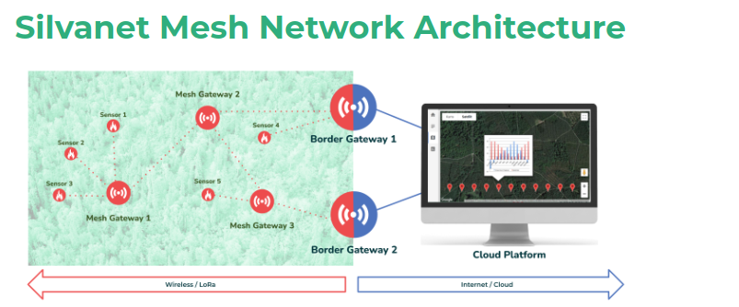
- The Silvanet Mesh Gateway extends the range of communication by forwarding messages between sensors, Mesh Gateways, and Border Gateways.
- The Silvanet Wildfire Sensor is designed to monitor air quality within a radius of 80-100 meters and is attached directly to trees.
- On the software side, the Silvanet Cloud Platform receives data from the gateways and makes it accessible to users through Silvanet apps.
- The Silvanet Site Management app allows users to monitor and manage sites, providing fire alerts when sensors detect potential wildfires.
- The Silvanet Deployment app, designed for smartphones, assists users in locating and deploying Silvanet devices at designated locations.
- This integrated system aims to enhance forest monitoring and wildfire detection, enabling timely responses to mitigate fire risks.

1. SLoRaWAPS: A Wide-Area Positioning System Based on

LoRa Mesh
A wide area localization method and system based on LoRa Mesh are designed.This system capable of simultaneously running LoRa Mesh networking communication and LoRa wireless positioning tasks.

1.System Overview
- The system consists of a Server, a Gateway, a number of positioning Anchors and a number of Targets(end devices).

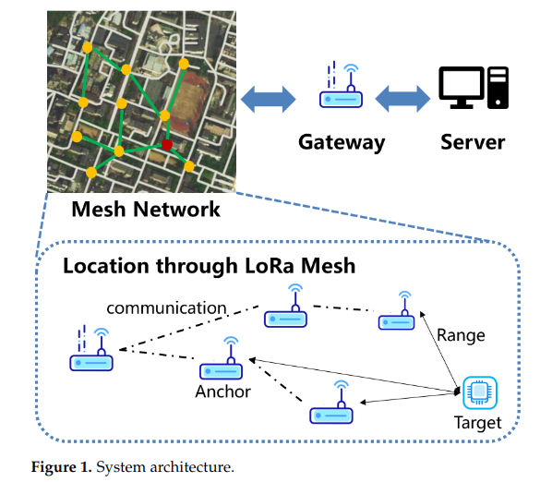

- Targets : They are sensors or actuators send LoRa modulated wireless messages to the Anchor or receive messages wirelessly back from the Anchor.
- Anchors : They are LoRa mesh module serve as anchor points to support the positioning of LoRa terminal devices
  - Location anchors are positioned within the area and their coordinates are known to the server.
  - Wireless networking between anchors and gateways is achieved using the LoRa Mesh protocol.
  - Distance data is obtained via Time of Flight (TOF) measurements between the anchor and the target.
  - Bidirectional transmission of data packets, including distance information and task instructions, occurs wirelessly between the gateway and the anchor through mesh networking.
  - Anchors can be powered by solar energy or large-capacity batteries, eliminating the need for external power or network cables during deployment.
- Gateway : The gateway serves as the primary node in the LoRa Mesh network, communicating wirelessly with anchor points and targets, while also connecting to the server through wired access for uploading and transmitting data.

- Server : The server acts as the central processing unit, gathering position coordinates and state information from all anchor points. It sends ranging instructions to and receives results from anchor points and labels via the gateway, using this data to estimate the label's location coordinates.

2. Hardware Design and LoRa Mesh protocol

The paper presents the hardware design, illustrates mesh networking details, and proposes ranging and localization algorithms.
- For hardware design, a hardware abstraction layer is added for cost control or power optimization.
- Moreover, a LoRa Mesh protocol with low power consumption and high reliability is designed
- The lack of a LoRa Mesh protocol standard, they rebuild and simplify the LoRa Mesh protocol stack and improve the packet format
- Compared with other wireless Mesh protocols, the route discovery and route maintenance process of the LoRa Mesh protocol designed in this paper which is simpler and more energy-efficient.
- The protocol also introduces the mechanism of channel activity detection (CMD) and packet Cyclic Redundancy Check (CRC) check to optimize packet congestion and improve communication reliability.

Hardware
- The system consists of gateways, anchors, and targets.
- The gateway and anchor consist of a LoRa radio module, a control module, an interface module, a low noise amplifier (LNA), and a high-gain antenna.
- The hardware structure of the target is much the same as the anchor, except that the LNA is removed, as shown in Figure

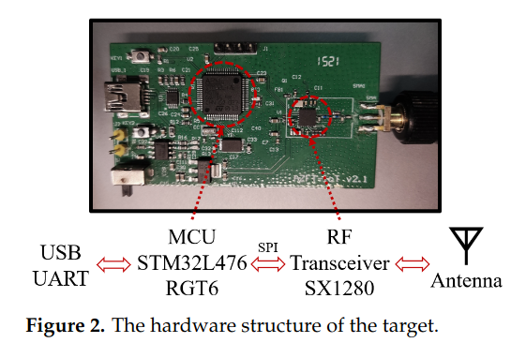

- RF Transceiver (SX1280) : The radio module utilizes the SX1280 chip, a SEMTECH-developed RF-integrated chip designed for ultra-long-range communication in the 2.4 GHz band.
  - It offers strong linearity and can handle significant interference. With a 10 dB receiving gain and an 11 dB transmitting gain, it includes an automatic discrimination circuit for rapid transceiver switching.
  - This feature enables it to function automatically without needing a control signal from an external control chip.
- MCU (STM32L476RGT) : The control module is based on STM32L476RGT6, a low-power ARM Cortex- M4 microprocessor.
  - The control module is responsible for controlling the RF module and uploading the data and is connected to the radio module through serial peripheral interface (SPI)
- USB : The interface module uses the serial port to network port chip to provide wired network access and data reporting (as a gateway).

- This design focuses on functional verification, so its size and low-power characteristics are not optimized.
- Despite that, all the following proposed algorithms are device-independent by adding a hardware abstraction layer, making it easy to port to other platforms for cost control or power optimization

LoRa Mesh Protocol Design
- The mesh networking protocol is an on-demand routing protocol. It discovers and maintains routes only when data needs to be sent, effectively reducing power consumption.
- They also design thelayered structure of the grid protocol to make it modular and maintainable. Furthermore,
- we propose a routing algorithm that balances efficiency and communication quality.
The Structure of the Mesh Protocol
The proposed mesh networking protocol consists of four layers: the physical layer, the link layer, the routing layer, and the application layer.
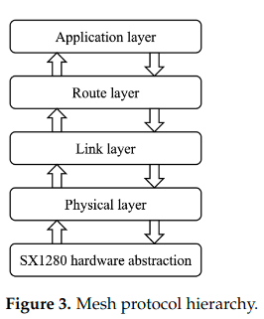

- 1. Physical layer :The physical layer communicates with the hardware and guarantees network reliability at the hardware level.
  - There is a packet queue in the physical layer,All sending packets and received packets will be serialized in the queue to reduce hardware conflicts while keeping the order of packets.
  - Channel activity detection (CAD) and random delay mechanism are used in the physical layer to reduce data collisions.
  - In addition, 32-bit Cyclic Redundancy Check (CRC32) is also used to reduce data errors.
- 2. link layer : The link layer ensures that packets passing to the upper layers are all packets to be processed by this node.
  - It defines the target and source IP for each hop, representing the previous and next hop nodes.
  - The node will only process the packet whose target IP is the same as its own IP or is a broadcast IP.
  - To avoid infinite flooding of broadcast packets, the link layer keeps track of visited nodes.
- 3. Route layer : The route layer is the key layer of our mesh protocol, maintaining a route table,executing the routing algorithm, and ensuring the best-effort delivery of the packet.
  - The route table contains information on the network collected from received packets.
  - When a Packet is to be sent, the route layer will use the route algorithm to choose a path from the route table, and create a route layer header.
  - We also maintain a waiting list in this layer,which is used to handle replies and re-transmit a packet if no reply is received in a specified resend interval time, a packet without a reply might be re-transmitted several times before declaring an error.
- 4. Application layer : The topmost layer is the application layer, whose role is to implement functions such as sending positioning instructions, handling messages, or communicating with the host computer

- The packet structure is shown in Figure

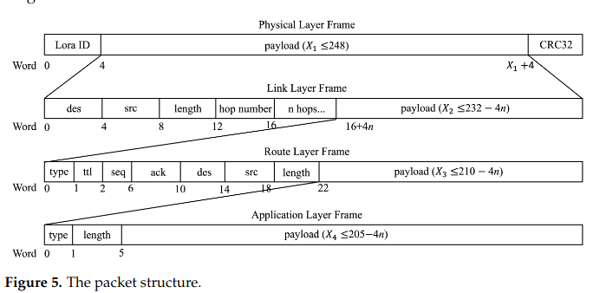

Route Discovery and Maintenance
- LoRa mesh protocol is a kind of on-demand routing protocol, when there is no load in the network, all of the nodes keep silent. When there is a load, the network starts the update and maintenance process.
- Step 1:
  - When starting to transmit a message, the node will look up the route table to find a valid route to its destination.
      - If the route exists, the packet will be transmitted following the path
      - If not, the node will start finding a route by sending a broadcast lookup packet.
  - Each node that received the broadcast packet without a valid route to the destination, it forwards or relays this broadcast to other neighboring nodes.
  - If received by the destination node or any node with a valid route to the destination, they will reply to the source node according to the path of the broadcast packet.

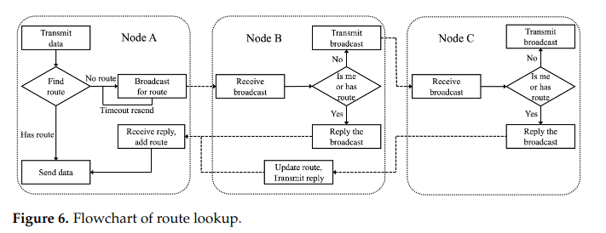

- Step 2 :
  - After sending the lookup packet, the source node adds it to a waiting list for timeout re-transmission.
  - Once the lookup packet reply is received, the suspended message packet is transmitted to the destination through the discovered route.
- Route Table Update:
  - During network activity, each node updates its route table by capturing packets from surrounding nodes.
  - Each route table entry has a valid time field, refreshed by new packets from the route path, and an RSSI field updated by captured packets.
  - If an entry's valid time expires, it becomes invalid.
  - If a route entry repeatedly fails during transmission tasks, it is also marked as invalid.

Distance Estimation Algorithm
- A distance estimation algorithm is designed using multi-sample data of time of flight (TOF) and RSSI.
- It aims to address the issue of LoRa range accuracy being affected by NLOS path propagation by fusing TOF and RSSI data through clustering to identify LOS channels and estimate distances.
- Experimental results show an average distance measurement error of about 6 meters.

Position Estimation Algorithm
- A position estimation algorithm is created to minimize posterior RSSI error.
- It calculates the error of position estimation coordinates and designs an evaluation criterion for position results.
- The algorithm can achieve meter-level positioning accuracy in outdoor scenes with high regional anchor point density.

Optimal Anchor Point Positioning
- The document discusses the optimal position of anchor points to address the lack of reference basis for anchor location.
- It uses electromagnetic simulation to simulate spatial signal distribution and designs a heuristic anchor location selection algorithm based on spatial signal distribution and prior knowledge.
- The goal is to find the best anchor location with the most effective coverage.

Summary of LoRaWAPS Outdoor Positioning System
In this paper, a low-cost and low-power outdoor positioning system called LoRaWAPS is designed, utilizing multi-anchor wireless mesh networking and multi-dimensional data fusion based on LoRa technology.
The system includes a hardware platform and a low-power on-demand routing protocol for efficient mesh networking.
It also features distance estimation and position estimation algorithms for high-precision positioning through wireless mesh, reducing interference for applications like outdoor warehouse tracking and personnel management.
However, challenges remain in meeting future needs for outdoor wide-area positioning with low power consumption and low cost.
Future improvements include enhancing anchor point structures with multiple antenna technologies and achieving multi-target real-time localization with limited spectrum resources.

2. LoRa Mesh Networking with Simple Arduino-Based Modules

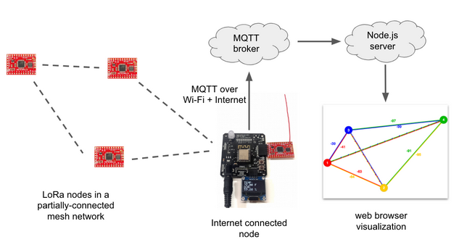
Project source code at GitHub: lora-mesh
In this project, built a mesh network of 4 Arduino-Based LoRa modules and devised a way to visualize the network’s behavior in realtime. Using a realtime visualization we can see how the network forms and how it heals itself when network nodes become unreachable.Explains how mesh networking is achieved using LoRa radios and the RadioHead library, particularly focusing on a specific test network (#3) defined in the library. Here's a breakdown of the key points:
- RadioHead Library and Mesh Networking: The RadioHead library is used to implement mesh networking with LoRa radios. Mesh networking allows nodes in the network to communicate with each other directly or through intermediate nodes, forming a robust and flexible network.
- Arduino Sketch for Moteino Boards: An Arduino sketch is written to run on Moteino boards, with each board representing a node in the mesh network. Each node has a unique identity stored in its EEPROM, allowing for identification within the network.
- Testing Mesh Networks: Testing mesh networks can be challenging due to the need to position nodes in specific ways to simulate real-world scenarios. The RadioHead library provides predefined test networks that simulate different communication scenarios, making testing easier and more controlled.
- Test Network #3: This test network is described as having nodes 1 and 4 unable to communicate directly, and nodes 2 and 3 also unable to communicate directly. This setup helps visualize how messages are routed through the network.
- Routing Tables: Each node maintains a routing table that describes which nodes it can communicate with directly and which nodes require message routing through other nodes. The table also includes signal strength information for direct communications.
- JSON Representation of Routing Table: The routing table is represented in JSON format, where each record contains information about node identities, routes, and signal strengths. This information is exchanged between nodes to update routing information in the network.
- Message Structure: Messages exchanged between nodes contain the routing table data, allowing nodes to update their routing information based on the messages received from other nodes.

